**Project Title:** Construction of emergency latrines in Thawra 76 Gathering site

Omdurman

**Contract Reference No:**

**Technical Referents:** Eddy KILAMBA (WatSan TL); Abjad Al Sarraj (WatSan Manager)

**Purpose:**

To improve the sanitary conditions and contribute towards the public health of the population living in the Al Eskan Thawra 76 IDP site, MSF plans to contract the construction 240 Ventilated Improved Pit (VIP) Latrines.

This will consist of 60 blocks, each with 4 latrines, consisting of an excavated pit, reinforced concrete slab and a steel frame and corrugated sheet superstructure. Additional requirements include the installation of solar lighting, and design elements to improve the user experience for women and girls.

**MSF Engineer**

MSF designates ‘Abjad Al Sarraj’ as supervising engineer responsible for inspection and approval of works. Any changes to the agreed design must be approved in writing by the supervising engineer.

**Specifications:**

1. **Latrine Locations**
   * The specific locations of latrines within the site will be determined by MSF and the community and will be communicated to the contractor prior to the start of construction.
2. **Site Preparation**

* The construction areas must be cleared of all debris and vegetation before construction work is started
* All working areas and excavations should be clearly marked to prevent access to the community during construction, particular care must be taken to prevent access to excavations, particularly at night.

1. **Construction of Latrine Pits**

* Pit dimensions are to be: Length 4m, width 1m, Depth 3m
* Any partial pit collapse during excavation or construction must be inspected by the MSF supervising engineer before work continues. The supervising engineer may require additional reinforcement of the pit
* Masonry will be laid around the perimeter of the pit to support the concrete slab. The masonry will have a total depth of 0.3m, with 0.1m above the ground surface. The interior dimensions of the masonry will be: Length 4m, Width 1m.

1. **Latrine Slabs**

Latrine slab dimensions shall be: Length 4.3m, Width, 1.3m, Depth 0.1m

Latrine slabs shall be made from reinforced concrete, with ratio Cement:Sand:Gravel 1:2:4

Concrete shall be reinforced with a grid of 6mm rebar, 150mm centers, as shown below

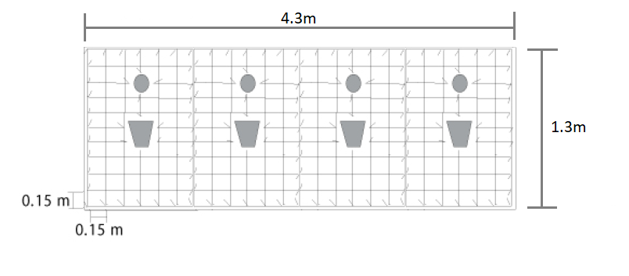

Rebar shall be placed on cement spacers, 30mm from the bottom of the slab

The drop hole should have dimensions as shown below, and shall be centered on the slab

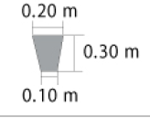

Four 100mm holes shall be cast into each slab for the installation of the vent pipes, these shall be 300mm from the back of the slab, and aligned with the drop hole.

Concrete shall be cured for 7 days before placing onto the pit, and shall be kept damp during this time

1. **Construction of Superstructure**

* The dimensions of the superstructure for each block shall be:
  + Length 4m, Width 1m, Height at rear 2m, Height at doors 2.2m
* The structure of the frame to be made from welded steel box section, 1m on centre.
* Each block consists of 4 separated cubicles
* Each cubicle to have a door with dimensions: Width 0.8m, Height 2m
* The structure and door to be covered with corrugated sheet metal, fitted overlapping to prevent gaps. Note: there should be a 0.2m gap above the door for airflow
* All doors to be fitted with locks on the inside and outside to allow closure from either side
* All cubicles to include a metal shelf with dimensions: Width 0.3m, Depth 0.2m, approximately 0.5m from floor
* All cubicles to include two hooks on the inside of the door, suitable for hanging clothing or a bag.

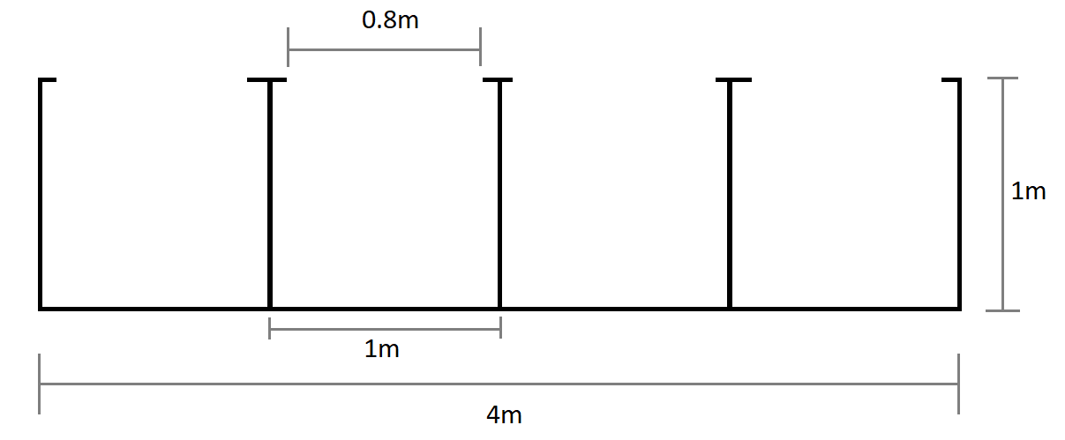

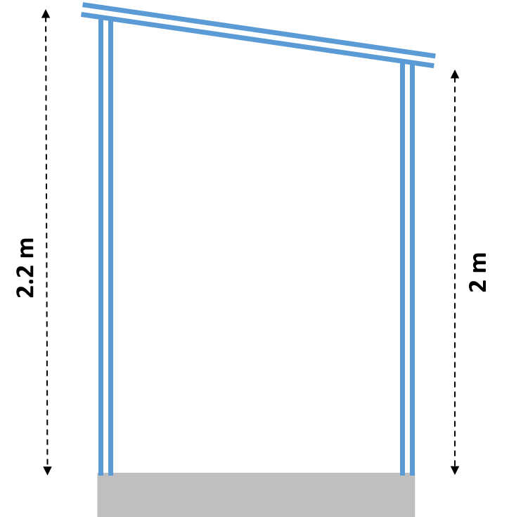

1. **Ventilation pipe**

* Each cubicle to have a ventilation pipe, with dimensions: Diameter 0.2m, length 3m.
* Ventilation pipe to be fitted into the concrete slab with no gaps, and to extend through the roof with no gaps
* Each ventilation pipe to be covered with securely attached wire mesh, with 2-4mm openings, as shown below

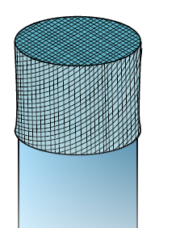

1. **Lighting**

* Each block of latrines to be fitted with a 30W Battery powered solar floodlight
  + The floodlight must be securely fixed to the roof of the structure to prevent theft
  + The light must automatically switch on at night
  + The light must have sufficient battery to operate continuously for 8 hours
* Each Cubicle must have a 5W solar light installed
  + The light should have a motion detector, and only switch on when the cubicle is in use
  + The light should be securely fastened to the ceiling of the cubicle to prevent theft